**APP CONNECT installation in Linux**

**--https://medium.com/@ahmed.siddiqui423/install-app-connect-enterprise-on-windows-linux-fa28af1e2162**

**Procedure:**

Step 1: Check that your target computer meets the initial hardware, Storage, and software requirements.

Step 2: Understand the security for running IBM App Connect Enterprise.

**Installing IBM App Connect Enterprise on Linux:**

* You can install IBM® App Connect Enterprise on Linux, either for use by a single user or for use by multiple users.

The following steps for installation:

1. As a user without administrative privileges, you can create a single-user installation of IBM App Connect Enterprise in your home directory. This single-user installation is then accessible only by your user ID.
2. As a user with administrative privileges, you can create a shared installation of IBM App Connect Enterprise. To authorize any users of the computer to access the shared installation of IBM App Connect Enterprise, add the users to the mqbrkrs group by using the security facilities that are provided by your operating system.

To install IBM App Connect Enterprise, complete the following steps:

1. Log in to the system where you are installing IBM App Connect Enterprise.
   * If you are deploying a single-user installation, log in with your personal user ID.
   * If you are deploying a shared installation, log in by using one of the following methods:
     + Log in as root or as a super user who has write access to the /var directory.
     + Log in as a non-root user who is a member of mqbrkrs and has write access to the /var/mqsi directory.

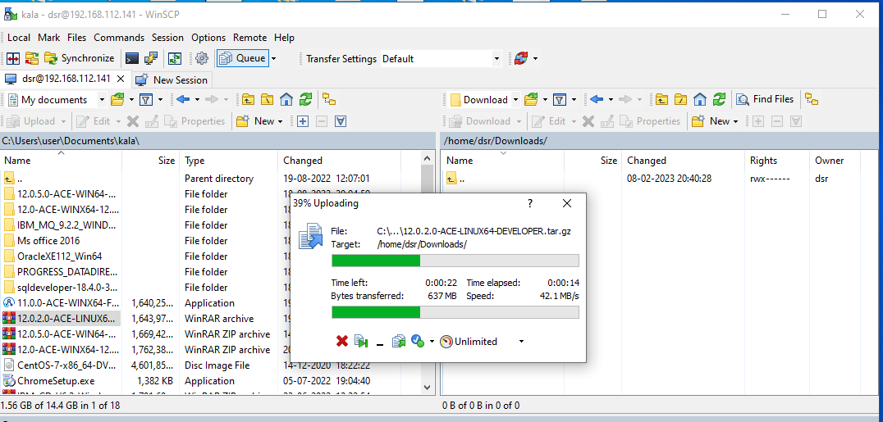

**Copy and paste Zipped Software to Downloads folder. Open CLI , Navigate to /home/user folder and run below command to extract the contents of zip file.**

**tar -xzvf /home/user/Downoads/12.0.2.0-ACE-LINUX64-DEVELOPER.tar.gz**

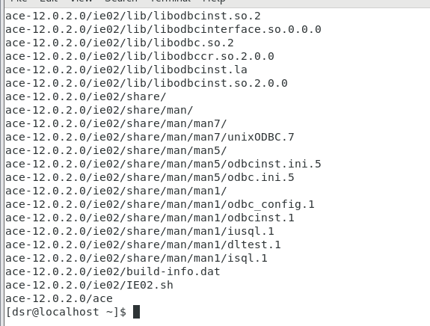

**This will create a directory named ace-12.0.2.0 under /home/user as shown below.**

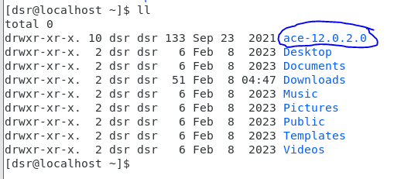

1. Accept the IBM App Connect Enterprise license by completing the following steps:
   1. Navigate to the installation directory.

For example, install_dir/ace-12.0.n.0 where install_dir is the directory where you unpacked the installation image.

* 1. Type one of the following commands:
     + For a single-user installation:
       - ./ace accept license. If you use this command, you are prompted to accept the license.
       - ./ace accept license silently. If you use this command, the license is accepted even though the license dialog is not displayed.

The following directory is created: $HOME/aceconfig. This directory is the work path for IBM App Connect Enterprise, and stores the IBM App Connect Enterprise configuration files.

* + - For a shared installation:
      * ./ace make registry global accept license. If you use this command, you are prompted to accept the license.
      * ./ace make registry global accept license silently. If you use this command, the license dialog is suppressed and the license is automatically accepted.

The following directory is created: /var/mqsi. This directory is the work path for IBM App Connect Enterprise, and stores the IBM App Connect Enterprise configuration files.

**Navigate to this installed directory using : cd ace-12.0.2.0/ and run below command.**

**c**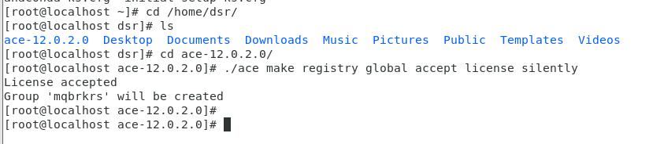

**This will create a directory /var/mqsi and its files as shown below**

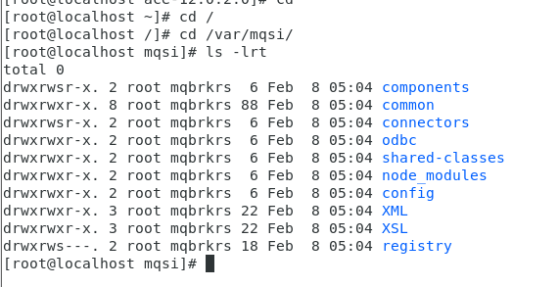

**On Linux, the user ID that installed IBM App Connect Enterprise is not automatically added to the mqbrkrs group. If you want to use this user ID with IBM App Connect Enterprise, you must add it to mqbrkrs group.**

**Create Group by name mqbrkrs as follow**

**> groupadd mqbrkrs**

**To check if group is added or not and its details type**

**> cat /etc/group**

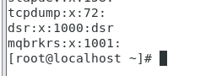

**Now add user to this group using command**

**> sudo usermod -aG mqbrkrs dsr**

**Now initialize the command environment, For this, Navigate to /ace-12.0.3.0/server/bin. (or) Run the following command from home directory as below.**

**. ace-12.0.3.0/server/bin/mqsiprofile**



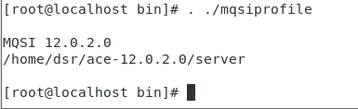

**Note:** On Linux, the user ID that installed IBM App Connect Enterprise is not automatically added to the mqbrkrs group. If you want to use this user ID with IBM App Connect Enterprise, you must add the user ID to the mqbrkrs group.

**Now run the below command to create an Integration Server, I will create it with a name aceserver**

**IntegrationServer — work-dir /home/ahmed/aceserver**

**The mqsiprofile needs to be sourced for the broker commands to run. Below is the command to add mqsiprofile to bash so that it doesn't ask every time a new terminal is opened.**

**echo “. /home/dsr/ace-12.0.2.0/server/bin/mqsiprofile” >> ~/.bashrc**

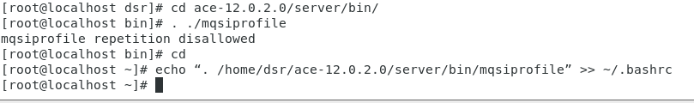

**Uninstalling IBM App Connect Enterprise on Linux and UNIX systems**

**Last Updated: 2023-10-02**

**You can uninstall IBM® App Connect Enterprise on Linux and UNIX systems by using the same user ID that you used to install the product.**

**Before you begin**

**Delete any integration servers that are not required, by removing the contents of their work directories.**

**Procedure**

**Log on with the user ID that you used to install IBM App Connect Enterprise.**

**Delete the IBM App Connect Enterprise entities that you do not want to keep:**

**The IBM App Connect Enterprise installation directory. For example, install_dir/ace-12.0.n.0.**

**(Linux only) The IBM App Connect Enterprise Toolkit workspace directory. For example, $HOME/IBM/ACET12/workspace. Do not delete the workspace if you want to keep any development resources that you created, such as applications or libraries. You can use existing applications and libraries with another installation of IBM App Connect Enterprise.**

**The IBM App Connect Enterprise work path directory. For example, $HOME/iibconfig for a single-user deployment or /var/mqsi for a shared deployment. Do not delete the work path directory if you want to keep any integration nodes and integration servers that you created. You can use existing integration nodes and integration servers with another installation of IBM App Connect Enterprise.**